**FECHAS IMPORTANTES**

* **409: Invasión tribus germánicas/llegada vándalos, suevos y alanos.**
* **414: llegada Visigodos.**
* **476: caída del Imperio Romano de Occidente. Comienzo de la Edad Media.**
* **711: musulmanes invaden la península ibérica. El estado visigodo fue derrotado en la batalla de Guadalete por los musulmanes.**
* **800: Carlomagno es proclamado emperador.**
* **843: termina su imperio.**
* **962- 1806: surge el sacro Imperio Romano.**
* **1095: las primeras cruzadas dirigidas por el Papa. Cristianos contra Musulmanes para reconquistar las tierras sagradas.**
* **1212: batalla de las Navas de Tolosa. Momento decisivo en la reconquista de los cristianos contra los musulmanes. Marcó una expansión de los cristianos y el definitivo retroceso de Al-Andalus.**
* **1291: últimas cruzadas.**
* **1347: la peste negra en Europa.**
* **1453: los otomanos conquistan Constantinopla (Estambul). Caída del Imperio Romano del Este.**
* **1469: se unen las coronas de Castilla y Aragón.**
* **1492: el descubrimiento de América por Cristóbal Colón y el final de la reconquista con la conquista del último reino musulmán de Granada por los reyes Católicos Isabel y Fernando.**
* **476 – 1492: Edad Media. Principios de la Edad Media (siglo 5 – siglo 10). Finales de la Edad Media (siglo 11 - siglo 15).**
* **SXI-SXV: La Reconquista de la península ibérica.**

**IMPORTANT DATES**

* + **409: Invasion of Germanic tribes/arrival of the Vandals, Suevi and Alans.**
  + **414: arrival of Visigoths.**
  + **476: fall of the Western Roman Empire. Beginning of the Middle Ages.**
  + **711: Muslims invade the Iberian Peninsula. The Visigothic state was defeated at the battle of Guadalete by the Muslims.**
  + **800: Charlemagne is proclaimed emperor.**
  + **843: his empire ends.**
  + **962- 1806: the Holy Roman Empire emerges.**
  + **1095: the first crusades led by the Pope. A war of Christians against Muslims to reconquer sacred lands.**
  + **1212: battle of Navas de Tolosa. It was a decisive moment in the reconquest of the Christians against the Muslims. It marked an expansion of the Christians and the definitive retreat of Al-Andalus.**
  + **1291: the last crusades.**
  + **1347: the Black Death in Europe.**
  + **1453: Ottomans conquer Constantinople (Istanbul). The fall of the Eastern Roman Empire.**
  + **1469:** **the crowns of Castile and Aragon are united.**
  + **1492: the discovery of America by Christopher Columbus and the end of the reconquest with the conquest of the last Muslim kingdom of Granada by the Catholic kings Isabella and Ferdinand.**
  + **476 - 1492: Middle Ages. Early Middle Ages (5th century - 10th century). Late Middle Ages (11th century - 15th century).**
  + **SXI-SXV: The Reconquest of the Iberian Peninsula.**

**RESUMEN DE LA CAÍDA DEL IMPERIO ROMANO, LA LLEGADA DE LOS MUSULMANES A LA PENÍNSULA IBÉRICA Y LA RECONQUISTA DE LOS CRISTIANOS**

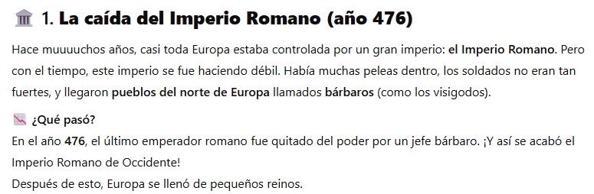

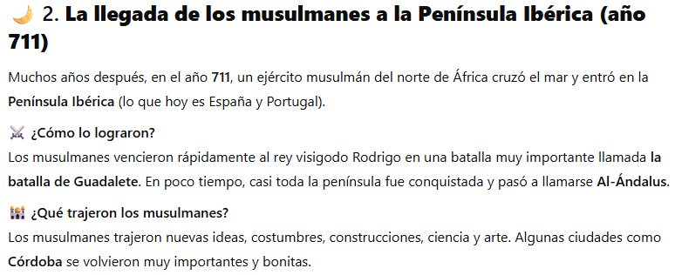

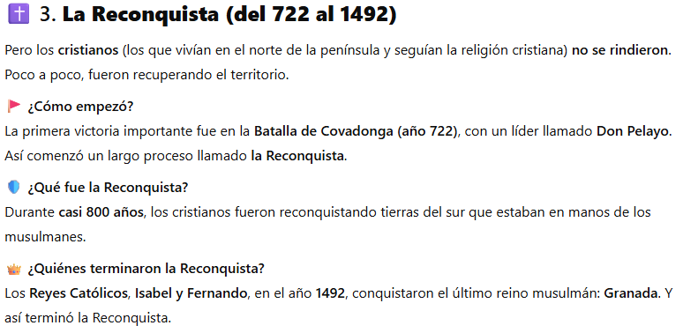

700 años

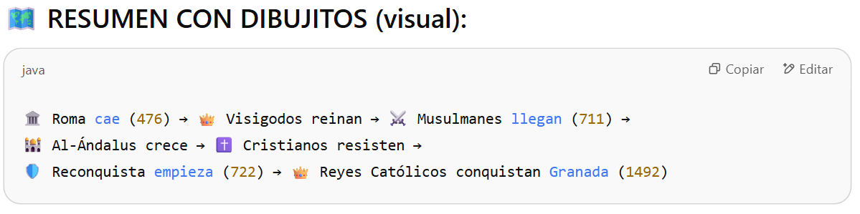

**SUMMARY OF THE FALL OF THE ROMAN EMPIRE, THE ARRIVAL OF THE MUSLIMS IN THE IBERIAN PENINSULA AND THE RECONQUEST BY THE CHRISTIANS**



**1. The fall of the Roman Empire (year 476)**

Many, many years ago, almost all of Europe was controlled by a great empire: the Roman Empire. But over time, this empire became weaker and weaker. There was a lot of fighting inside, the soldiers were not so strong, and people from the north of Europe called barbarians (like the Visigoths) arrived.

** What happened?**

In **476**, the last Roman emperor was removed from power by a barbarian chieftain. and so ended the Western Roman Empire! After this, Europe was filled with small kingdoms.

**2. The arrival of the Muslims to the Iberian Peninsula (year 711)**

Many years later, in the year 711, a Muslim army from North Africa crossed the sea and entered the Iberian Peninsula (what is now Spain and Portugal).

⚔ **How did they do it?**

The Muslims quickly defeated the Visigothic King Rodrigo in a very important battle called the Battle of Guadalete. In a short time, almost the entire peninsula was conquered and became known as Al-Andalus.

**What did the Muslims bring?**

The Muslims brought new ideas, customs, constructions, science and art. Some cities like Cordoba became very important and beautiful.



**3. The Reconquest (from 722 to 1492)**

But the Christians (those who lived in the north of the peninsula and followed the Christian religion) did not surrender. Little by little, they were recovering the territory.

**How did it start?**

The first important victory was in the Battle of Covadonga (year 722), with a leader named Don Pelayo. Thus began a long process called the Reconquest.

**What was the Reconquest?**

For 700 years (almost 800 years), the Christians were reconquering southern lands that were in the hands of the Muslims.

** Who finished the Reconquest?**

The Catholic Monarchs, Isabella and Ferdinand, in the year 1492, conquered the last Muslim kingdom: Granada. And thus ended the Reconquest.

