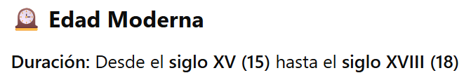

**Años aproximados:** 1492-1789

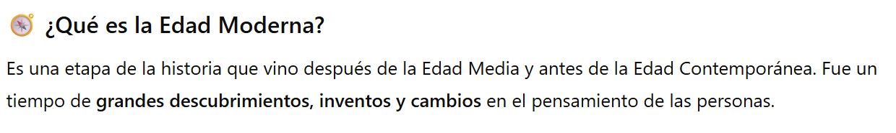



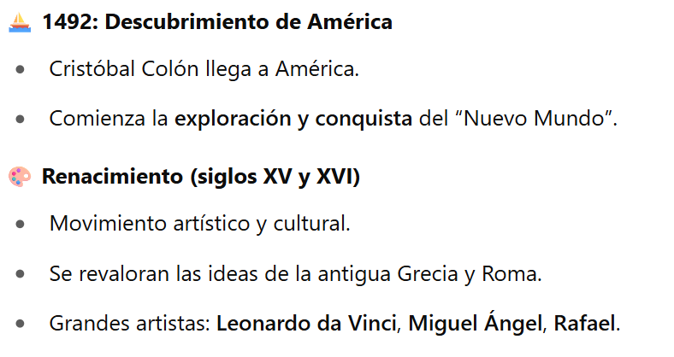

* Belleza y armonía.

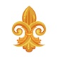 **Barroco (XVI y XVIII)**

* Movimiento artístico y cultural.
* Problemas económicos pero grandes obras maestras.
* Grandes artistas: **Shakespeare, Cervantes**.
* Expresión y movimiento de personas ordinarias.

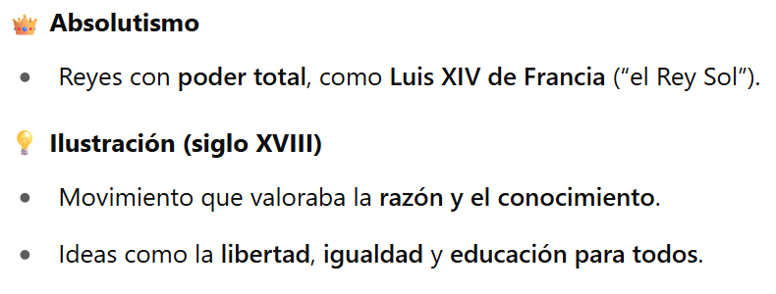

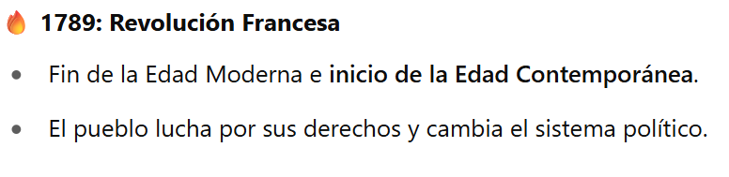

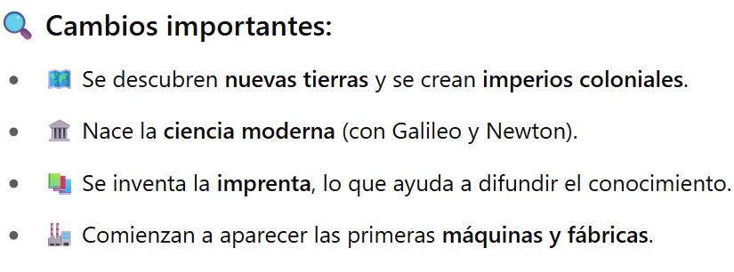

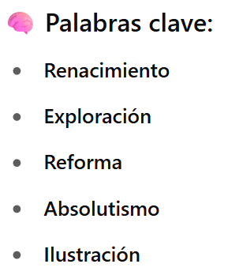

* **Barroco**

**Modern Age**

**Duration:** From the 15th century (15) to the 18th century (18)

1492-1789

**What is the Modern Age?**

* It is a stage of history that came after the Middle Ages and before the Contemporary Age.
* It was a time of great discoveries, inventions and changes in people's thinking.



**Main events:**

* **1492:** Discovery of America.
* Christopher Columbus arrives in America.
* The exploration and conquest of the “New World” begins.

 **Renaissance (15th and 16th centuries)**

* Artistic and cultural movement.
* The ideas of ancient Greece and Rome are revalued.
* Great artists: **Leonardo da Vinci, Michelangelo, Raphael.**

 **Baroque (XVI and XVIII)**

* Artistic and cultural movement.
* Economic problems but great masterpieces.
* Great artists: **Shakespeare, Cervantes.**
* Expression and movement of ordinary people.

**Absolutism**

* Kings with total power, such as Louis XIV of France (“the Sun King”).

**Enlightenment (18th century)**

* Movement that valued reason and knowledge.
* Ideas such as liberty, equality and education for all.

**1789: French Revolution**

* End of the Modern Age and beginning of the Contemporary Age.
* The people fight for their rights and change the political system.



**Major changes:**

* New lands are discovered and colonial empires are created.
* Modern science is born (with Galileo and Newton).
* The printing press is invented, which helps to spread knowledge.
* The first machines and factories begin to appear.

**Keywords:**

* Renaissance
* Exploration
* Reformation
* Absolutism
* Enlightenment
* Baroque