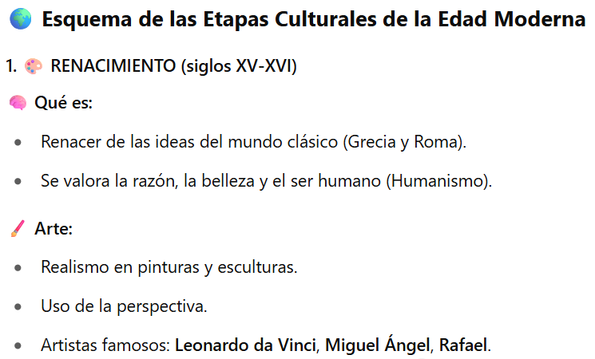

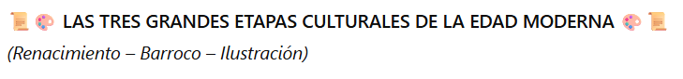

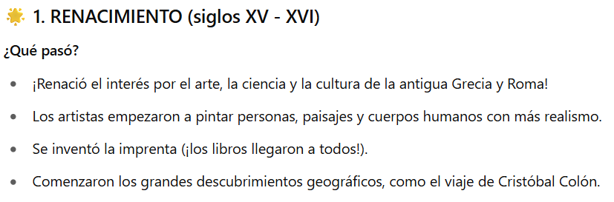



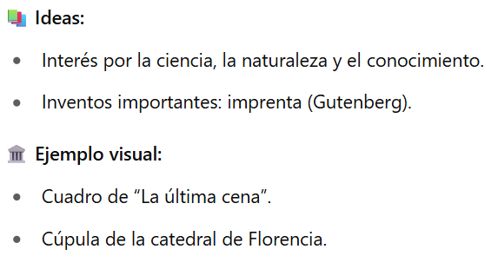

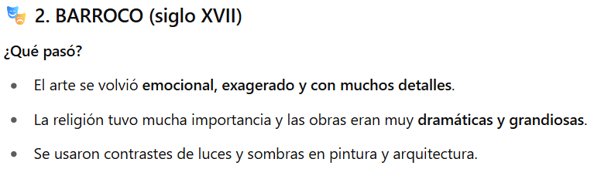

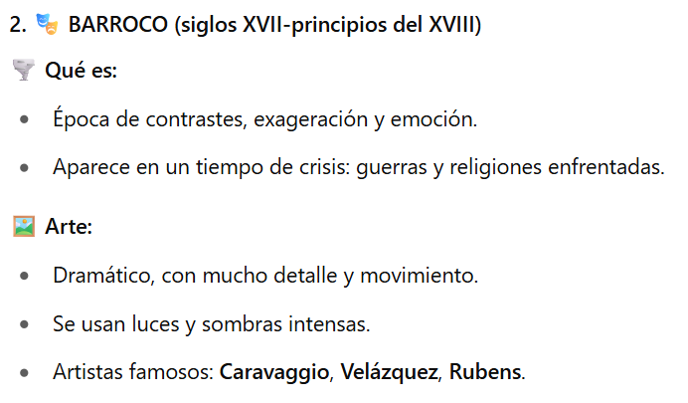

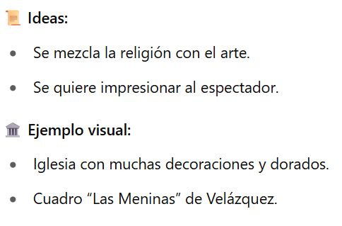

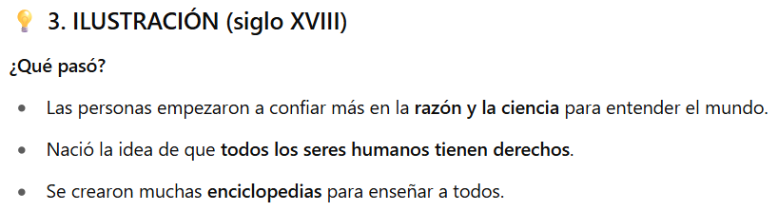

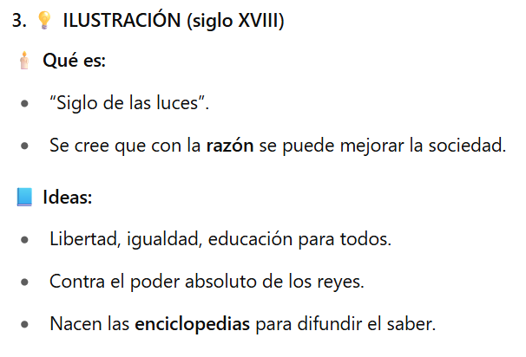

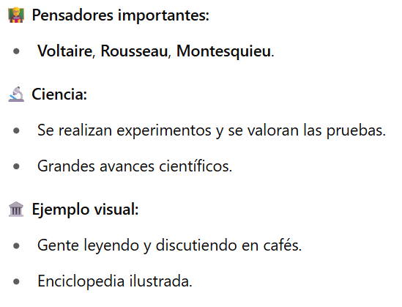

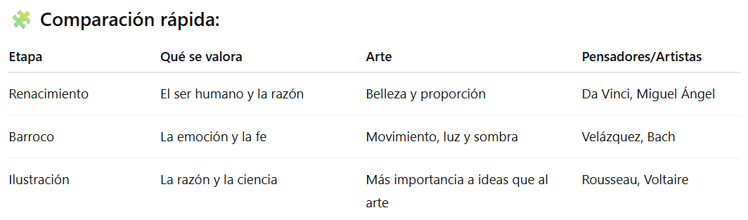



**Outline of the Cultural Stages of the Modern Age**



**THE THREE GREAT CULTURAL STAGES OF THE MODERN AGE**

(Renaissance - Baroque - Enlightenment).



**1. RENAISSANCE (15th - 16th centuries)**

**What happened?**

* Interest in the art, science and culture of ancient Greece and Rome was reborn!
* Artists began to paint people, landscapes and human bodies more realistically.
* The printing press was invented (books reached everyone!).
* Great geographical discoveries began, such as the voyage of Christopher Columbus.

 **What it is:**

* Revival of the ideas of the classical world (Greece and Rome).
* Reason, beauty and the human being are valued (Humanism).

 **Art:**

* Realism in paintings and sculptures.
* Use of perspective.
* Famous artists: **Leonardo da Vinci, Michelangelo, Raphael.**

**Ideas:**

* Interest in science, nature and knowledge.
* Important inventions: printing press (Gutenberg).

**Visual example:**

* “The Last Supper” painting.
* Dome of the cathedral of Florence.

**2. BAROQUE (17th century)**

**What happened?**

* Art became emotional, exaggerated and with a lot of details.
* Religion was very important and the works were very dramatic and grandiose.
* Contrasts of light and shadow were used in painting and architecture.

**What it is:**

* Time of contrasts, exaggeration and emotion.
* It appears in a time of crisis: wars and clashing religions.

 **Art:**

* Dramatic, with much detail and movement.
* Intense lights and shadows are used.
* Famous artists: **Caravaggio, Velázquez, Rubens.**

**Ideas:**

* Religion is mixed with art.
* The aim is to impress the viewer.

 **Visual example:**

* Church with many decorations and gilding.
* Painting “Las Meninas” by Velázquez.

**3. ILLUSTRATION (18th century)**

**What happened?**

* People began to rely more on reason and science to understand the world.
* The idea that all human beings have rights was born.
* Many encyclopedias were created to teach everyone.

**What it is:**

* “Age of Enlightenment”.
* It is believed that with reason you can improve society.

**Ideas:**

* Liberty, equality, education for all.
* Against the absolute power of kings.
* Encyclopedias are born to spread knowledge.

**Important thinkers:**

* Voltaire, Rousseau, Montesquieu.

 **Science:**

* Experiments are conducted and evidence is valued.
* Major scientific breakthroughs.

**Visual example:**

* People reading and discussing in cafes.
* Illustrated encyclopedia.



**Quick comparison:**

* **Stage:** Renaissance

**What is valued:** The human being and reason Beauty and proportion

**Art Thinkers/Artists:** Da Vinci, Michelangelo

* **Stage:** Baroque

**What is valued:** Emotion and faith Movement, light and shadow

**Art Thinkers/Artists:** Velázquez, Bach

* **Stage:** Enlightenment

**What is valued:** Reason and science

**Art Thinkers/Artists:** More importance to ideas than to art. Rousseau, Voltaire.