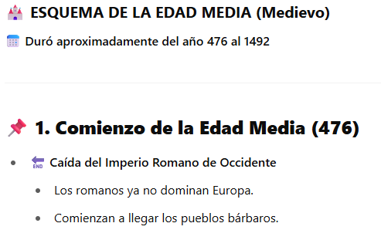

**LA EDAD MEDIA ESTÁ DIVIDIDA EN DOS PERIODOS :**

* PRINCIPIOS DE LA EDAD MEDIA (DEL S.V AL S.X).
* ALTA EDAD MEDIA O FINAL (DEL S.XI AL S.XV).



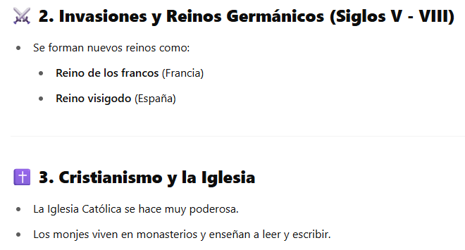

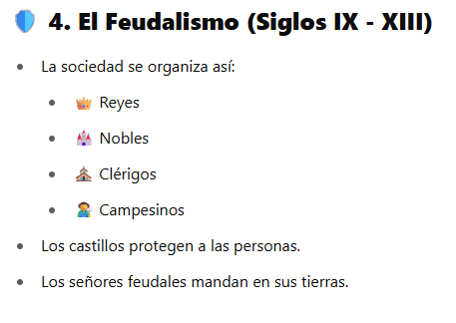

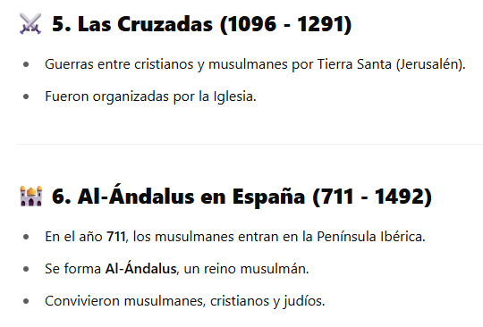

**1095**

**(THE FIRST CRUSADES STARTED IN 1095)**

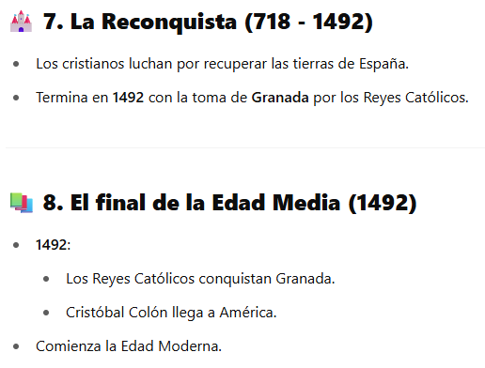

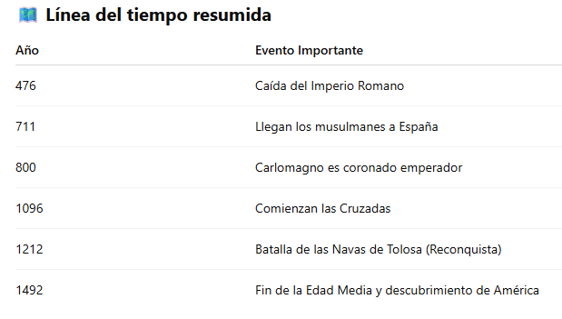

1095

_____________________________________________________________________________

* En el año **409 (SV):** invasión tribus germánicas y llegada de vándalos, suevos y alanos.
* En el año **414 (SV):** llegada Visigodos.

También:

* **476:** La caída del Imperio Romano de Occidente por los pueblos bárbaros. El Imperio Romano de Oriente continuó existiendo.
* **711:** Los musulmanes echaron a los Visigodos en la batalla de Guadalete.
* **1212:** La batalla de Las Navas de Tolosa. Un ejército cristiano derrotó a musulmanes en un enfrentamiento decisivo para la Reconquista de la Península Ibérica.

**SCHEME OF THE MIDDLE AGES (Middle Ages)**

It lasted approximately from **476 to 1492**

________________________________________

**THE MIDDLE AGES ARE DIVIDED INTO TWO PERIODS:**

♣ EARLY MIDDLE AGES (FROM THE 5TH TO THE 10TH CENTURY).

♣ HIGH MIDDLE OR LATE MIDDLE AGES (FROM THE 11TH TO THE 15TH CENTURY).

**1. Beginning of the Middle Ages (476)**

- Fall of the Western Roman Empire

- Romans no longer dominate Europe.

- Barbarian peoples begin to arrive.

________________________________________

**⚔2. Germanic Invasions and Kingdoms (5th - 8th Centuries)**

- New kingdoms are formed such as:

- Kingdom of the Franks (France)

- Visigothic Kingdom (Spain)

________________________________________

**✝3. Christianity and the Church**

- The Catholic Church becomes very powerful.

- Monks live in monasteries and teach reading and writing.

**4. Feudalism (IX - XIII Century)**

Society is organized as follows:

- Kings

- Nobles

- ⛪ Clerics

- Peasants.

Castles protect people.

Feudal lords rule their lands.

________________________________________

**⚔ 5. The Crusades (1096 - 1291). The first crusades started in 1095.**

- Wars between Christians and Muslims for the Holy Land (Jerusalem).

- They were organized by the Church.

________________________________________

**6. Al-Andalus in Spain (711 - 1492)**

- In the year 711, the Muslims enter the Iberian Peninsula.

- Al-Andalus, a Muslim kingdom, is formed.

- Muslims, Christians and Jews coexisted.

________________________________________

**7. The Reconquest (718 - 1492)**

- The Christians fight to recover the lands of Spain.

- It ends in 1492 with the capture of Granada by the Catholic Monarchs.

________________________________________

**8. The end of the Middle Ages (1492)**

1492:

- The Catholic Monarchs conquer Granada.

- Christopher Columbus arrives in America.

The Modern Age begins.

**Summarized timeline**

Year Important Event:

**476** Fall of the Roman Empire

**711** Muslims arrive in Spain

**800** Charlemagne is crowned emperor

**1095** Crusades begin

**1212** Battle of Navas de Tolosa (**Reconquest**)

**1492** End of the Middle Ages and discovery of America

____________________________________________________________

* In **409 (SV)**: invasion of Germanic tribes and arrival of Vandals, Suevi and Alans.
* In **414 (SV):** arrival of Visigoths.

Also:

* **476:** The fall of the Western Roman Empire by the barbarian peoples. The Eastern Roman Empire continued to exist.
* **711:** The Muslims drove out the Visigoths in the battle of Guadalete.(Year 711)
* **1212:** The battle of Las Navas de Tolosa. A Christian army defeated Muslims in a decisive confrontation for the Reconquest of the Iberian Peninsula.