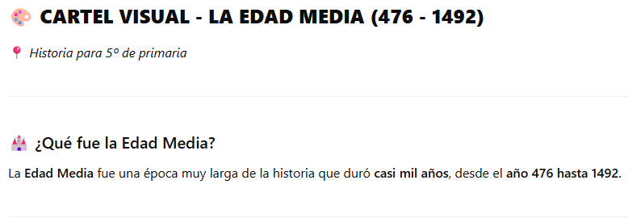

**LA EDAD MEDIA ESTÁ DIVIDIDA EN DOS PERIODOS:**

* PRINCIPIOS DE LA EDAD MEDIA (DEL S.V AL S.X).
* ALTA EDAD MEDIA O FINAL (DEL S.XI AL S.XV).

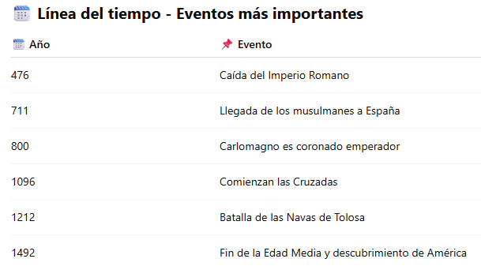

También:

**476:** La caída del Imperio Romano de Occidente por los pueblos bárbaros. El Imperio Romano de Oriente continuó existiendo.

**711:** Los musulmanes echaron a los Visigodos en la batalla de Guadalete.

**1212:** La batalla de Las Navas de Tolosa. Un ejército cristiano derrotó a musulmanes en un enfrentamiento decisivo para la Reconquista de la Península Ibérica.

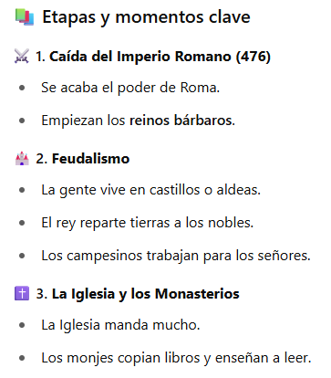

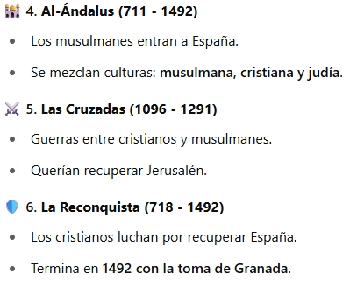

**1095**

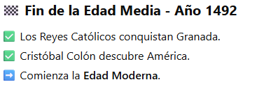

____________________________________________________________

* En el año 409 (SV): invasión tribus germánicas y llegada de vándalos, suevos y alanos.
* En el año 414 (SV): llegada Visigodos.

**VISUAL POSTER - THE MIDDLE AGES (476 - 1492)**

* What was the Middle Ages?

The Middle Ages was a very long time in history that lasted almost a thousand years, from the year **476 to 1492**.

**THE MIDDLE AGES ARE DIVIDED INTO TWO PERIODS:**

♣ EARLY MIDDLE AGES (FROM THE 5TH TO THE 10TH CENTURY).

♣ HIGH MIDDLE OR LATE MIDDLE AGES (FROM THE 11TH TO THE 15TH CENTURY).

________________________________________

**Timeline - Most Important Events**

**476** Fall of the Roman Empire

**711** Arrival of Muslims in Spain

**800** Charlemagne is crowned emperor

**1095** The Crusades begin

**1212** Battle of Navas de Tolosa (RECONQUIST)

**1492** End of the Middle Ages and Discovery of America and end of the reconquist with the invasion of Granada.

________________________________________

Also:

**476:** The fall of the Western Roman Empire by the barbarian peoples. The Eastern Roman Empire continued to exist.

**711:** The Muslims drove out the Visigoths in the battle of Guadalete.(Year 711)

**1212:** The battle of Las Navas de Tolosa. A Christian army defeated Muslims in a decisive confrontation for the Reconquest of the Iberian Peninsula.

Stages and key moments

**⚔ 1. Fall of the Roman Empire (476)**

- The power of Rome ends.

- The barbarian kingdoms begin.

**2. Feudalism**

- People live in castles or villages.

- The king distributes land to the nobles.

- Peasants work for the lords.

**✝️ 3. The Church and Monasteries**

- The Church rules a lot.

- Monks copy books and teach reading.

**4. Al-Andalus (711 - 1492)**

- Muslims enter Spain.

- Cultures mix: Muslim, Christian and Jewish.

⚔ **5. The Crusades (1095 - 1291)**

- Wars between Christians and Muslims.

- They wanted to recover Jerusalem.

**6. The Reconquest (718 - 1492)**

- The Christians fight to recover Spain.

- Ends in 1492 with the capture of Granada.

________________________________________

**End of the Middle Ages - Year 1492**

* The Catholic Monarchs conquer Granada and it is the end of the Reconquist.
* Christopher Columbus discovers America.
* The Modern Age begins.

____________________________________________________________

* In **409 (SV)**: invasion of Germanic tribes and arrival of Vandals, Suevi and Alans.
* In **414 (SV):** arrival of Visigoths.